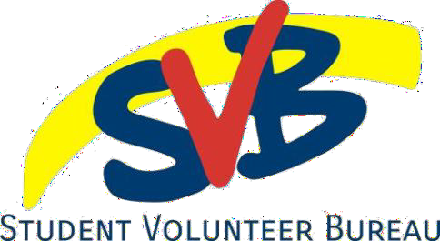
Organization Form
The VIP Program | GIVE
Name: _ Student #: Fall/Winter/Spring: __ _ Year: _ VIP Level: _ ___
Email: Volunteer Organization: _

- Why did you get involved with this organization?

- What did you do at this organization and what did you learn as a result?

- How will you incorporate this experience into your future?

I, ___ , verify that all of the information on this form is accurate.
Your initials: _ Date: _

PART B – Volunteer organization contact information

This form verifies that _ _ has completed a total of _ volunteer hours through this organization between December 5th, 2023 and April 5th, 2024 and has not received financial compensation or academic credit for their time.
Name: _ Date:
Signature
Contact email/telephone:

Access to Information and Protection Policy
All information requested by the VIP will be used solely for the administration and management of the program. Personal information is collected under the authority of the Access to Information and Protection of Privacy Act, 2015 (SNL2015 Chapter A-1.2) and is used for the purposes of administration and program planning. Questions about this collection and use of personal information may be directed to the Manager of the Student Experience Office at 709- 864-8819

